**GETTING STARTED WITH BASIC LINUX COMMANDS**

Linux has some basic set of commands that help us to open ,list, write and move directories to begin with to understand its basic functioning of CLI.

These are entered on the terminal :

1. *pwd*  is an abbreviation of ‘**p**rint **w**orking **d**irectory’. All it does is print out the shell’s current working directory.
2. *cd* We can change the working directory using the cd command, an abbreviation for ‘**c**hange **d**irectory’.
3. *cd home* From the root directory, the following command will move you into the “home” directory .

Creating directories and files:

*mkdir* is short for ‘**m**a**k**e **dir**ectory’. The following command can be used for making several directories.

mkdir dir1 dir2 dir3

To remove a directory, use the command -

rmdir directoryname

Listing files and directories:

The most basic **ls** command is without the use of options. It prints out files and directories in their bare format. With this command, you will not be able to see file types, dates, and permissions.

To execute this command, type **ls** in terminal window and press **Enter** on your keyboard.

The additional options detailed below give users more flexibility when using the **ls** command:

* **ls -F** in a terminal window to add “/” at the end of each directory. This command will help you to distinguish directories from files**.**
* **ls -m** When you type the ls -m command, the terminal prints out directories and files separated by a comma.
* **ls -Q** is used to add quotation marks to all directories and files as in the image below:
* **ls -i** To get the Inode (index node) number of all directories and files, type ls -i in your terminal.

### View Hidden Files:

**ls -a** When using the basic **ls** command, you can’t see hidden files and files starting with “**.**”. Type the **ls -a** command to display them .

**ls -la** To get a full list of hidden files, type **ls -la** in your terminal. The output displays information about the user, size of the file, and date and time of modification.

### Size Of Files and directories:

If you want to check the size of files and directories in a human readable format, type **ls -lh** in terminal.

### Moving and Copying files:

### mv command moves files, so the cp command **c**o**p**ies them (again, note the space before the dot):

### cp dir4/dir5/dir6/combined.txt .

### ls dir4/dir5/dir6

### ls

To move a file, use the command.

mv filename new_file_location

### Creating and Veiwing files:

The 'cat' server command is used to display text files. It can also be used for copying, combining and creating new text files.

To create a new file, use the command

1. cat > filename
2. Add content
3. Press 'ctrl + d' to return to command prompt.

To view a file, use the command -

cat filename

The syntax to combine 2 files is -

cat file1 file2 > newfilename

### Deleting files:The 'rm' command removes files from the system without confirmation.

### To remove a file use syntax -

### rm filename

## Renaming Directory

The 'mv' (move) command can also be used for renaming directories. Use the below-given format:

mv directoryname newdirectoryname

SUDO Command:

The sudo command allows you to run programs with the security privileges of another user (by default, as the superuser). It prompts you for your personal password and confirms your request to execute a command by checking a file, called sudoers, which the system administrator configures.

To use the sudo command, at the command prompt, enter:

*sudo command_you_want_to_execute*

SU command:

The su command allows you to become another user. To use the su command on a per-command basis, enter:

su user -c command

## The 'Man' command

Man stands for manual which is a reference book of a [Linux operating system](https://www.guru99.com/introduction-linux.html). It is similar to HELP file found in popular software.

To get help on any command that you do not understand, you can type man.

**chmod command in Linux with example**

In Unix-like operating systems, the chmod command is used to change the access mode of a file.

The name is an abbreviation of change mode.

Syntax :

chmod [reference][operator][mode] file...

The references are used to distinguish the users to whom the permissions apply i.e. they are list of letters that specifies whom to give permissions. The references are represented by one or more of the following letters:

**Reference Class Description**

**u**  owner file's owner

**g**  group users who are members of

the file's group

**o**  others users who are neither the

file's owner nor members of

the file's group

**a**  all All three of the above, same as ugo

The modes indicate which permissions are to be granted or removed from the specified classes. There are three basic modes which correspond to the basic permissions:

* r Permission to read the file.
* w Permission to write (or delete) the file.
* x Permission to execute the file, or the case of a directory, search it.

**Learning first about the top command in Linux:**

The top command is used to show the Linux processes. It provides a dynamic real-time view of the running system. Usually, this command shows the summary information of the system and the list of processes or threads which are currently managed by the Linux Kernel.

When we run this command it will open an interactive command mode where the top half portion will contain the statistics of processes and resource usage. And Lower half contains a list of the currently running processes. Pressing *q* will simply exit the command mode.

While interacting with top the 2 most important keys are ‘h or ?’ and ‘q’ or the quit key.

**Basic Commands:**

1. **top command:** Simply by entering the top in the terminal will display the list of all currently running processes along with
2. **PID:** Shows task’s unique process id.
3. **PR:** Stands for priority of the task.
4. **SHR:** Represents the amount of shared memory used by a task.
5. **VIRT:** Total virtual memory used by the task.
6. **USER:** User name of owner of task.
7. **%CPU:** Represents the CPU usage.
8. **TIME+:** CPU Time, the same as ‘TIME’, but reflecting more granularity through hundredths of a second.
9. **SHR:** Represents the Shared Memory size (kb) used by a task.
10. **NI:** Represents a Nice Value of task. A Negative nice value implies higher priority, and positive Nice value means lower priority.
11. **%MEM:** Shows the Memory usage of task.

The screenshot shows the running processes in my machine. Pressing q quits from top.

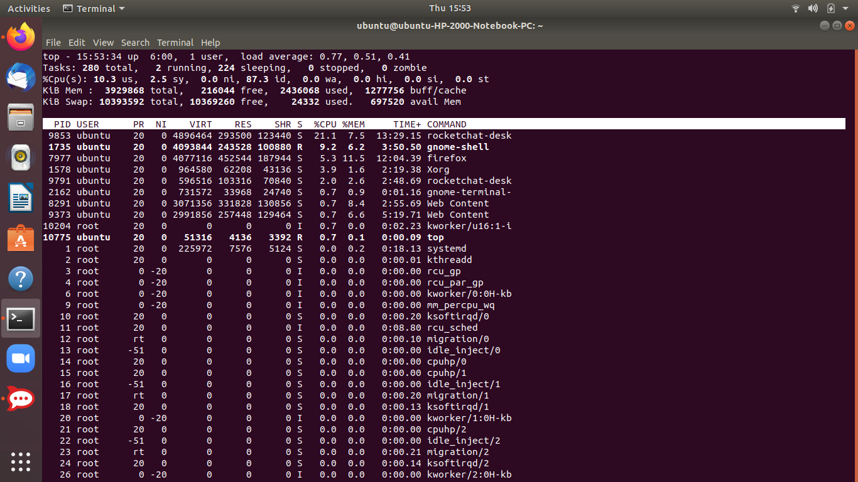

**2) Display Specific User Processes:** Simply to display the user processes enter $ top -u username in the terminal. Its shows all the user processes as shown in the below screenshot:

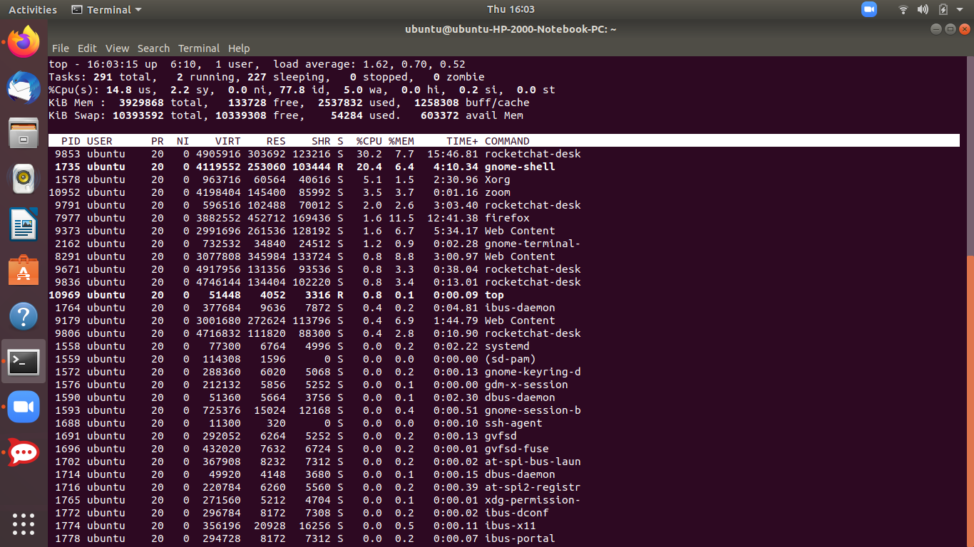

**3) Highlight Running Process in Top:** Press ‘z‘ option in running top command will display running process in color which may help you to identified running process easily:

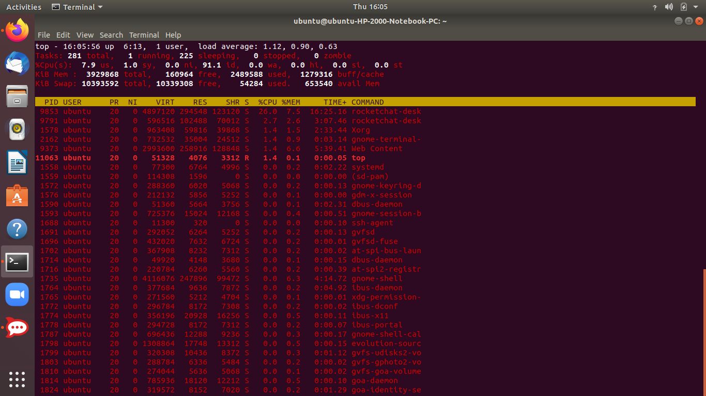

**4) Shows Absolute Path of Processes:** Press ‘c‘ option in running top command, it will display absolute path of running pro

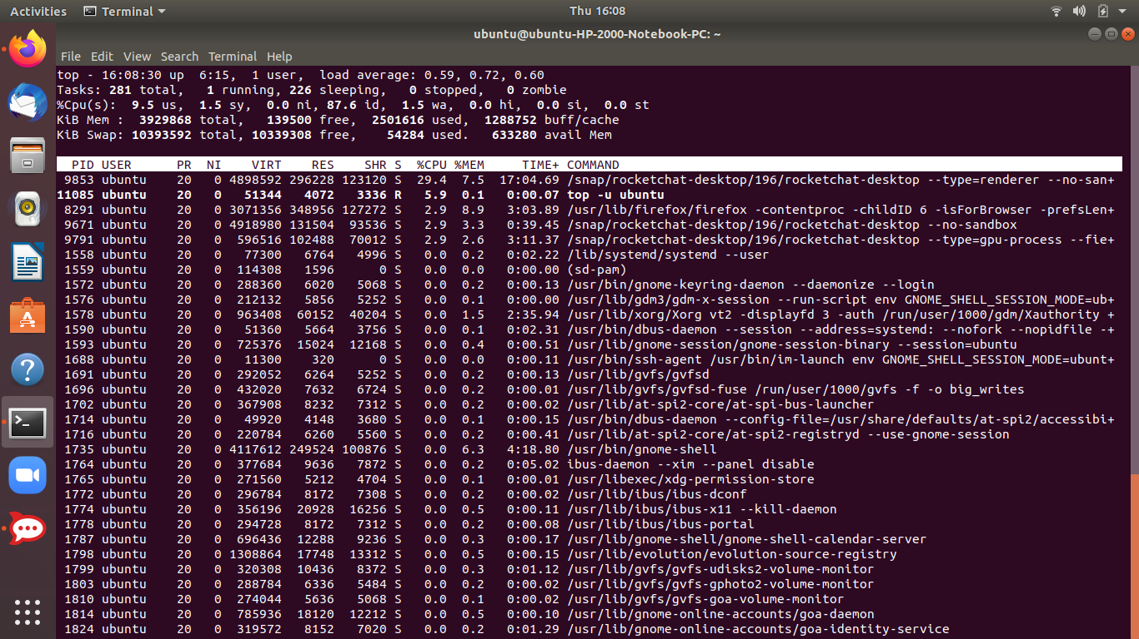

**5) Kill running process:** You can kill a process after finding PID of process by pressing ‘k‘ option in running top command without exiting from top window as shown below.*We have to note down a process-id before killing it.This is going to be different in htop.*

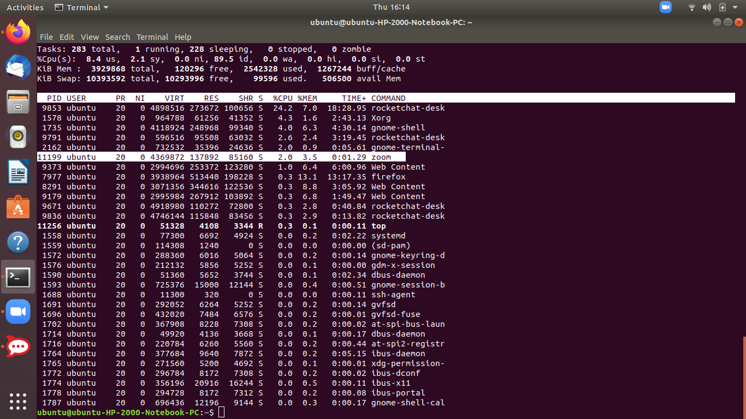

As seen from the above screenshot ,I tried to open zoom and then note its PID: 11199.

After pressing k ,I entered the same PID as shown in next screenshot.

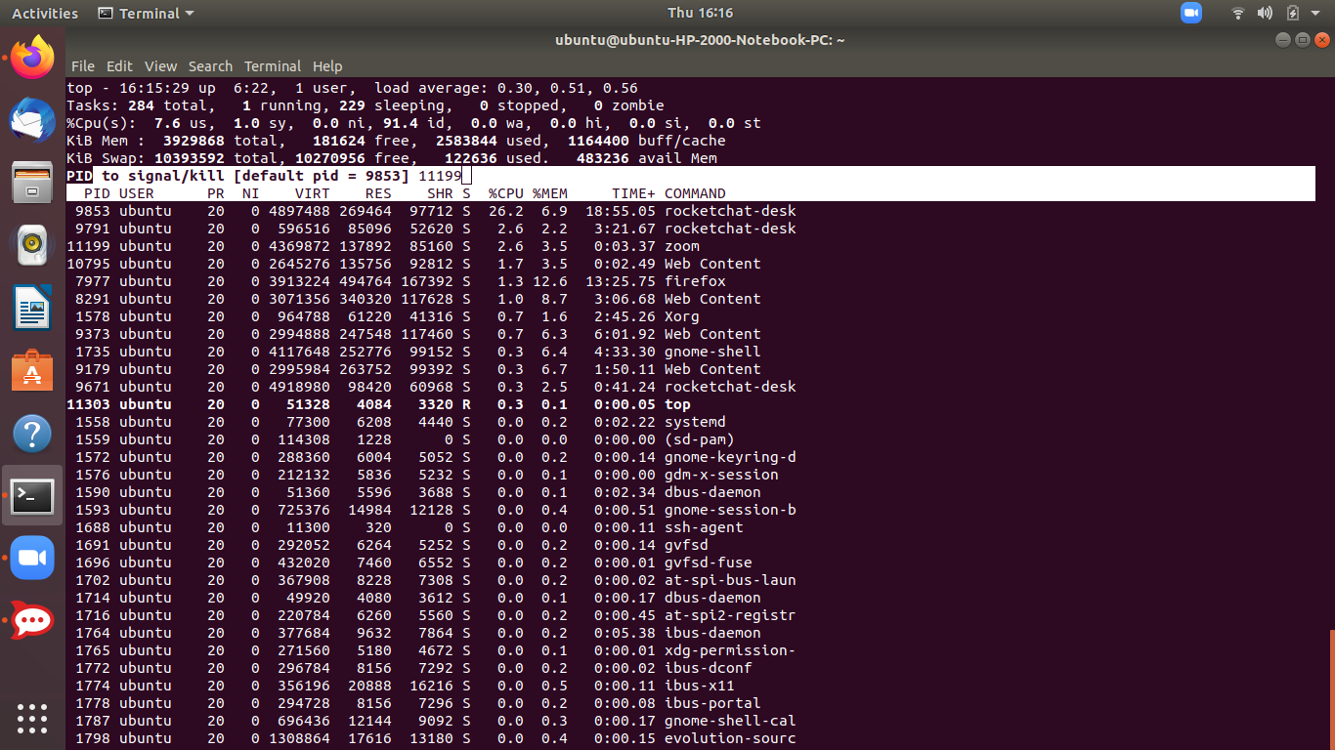

Now as we see the zoom app is closed and the process is no where in the running process list which means that its terminated.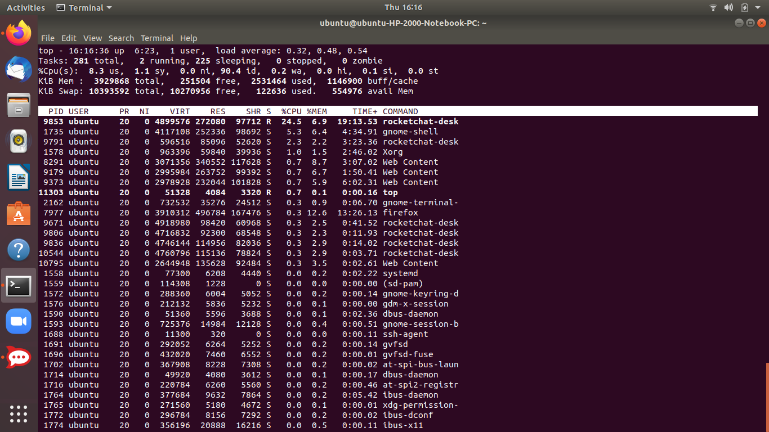

**6)Shows top command syntax:** top -h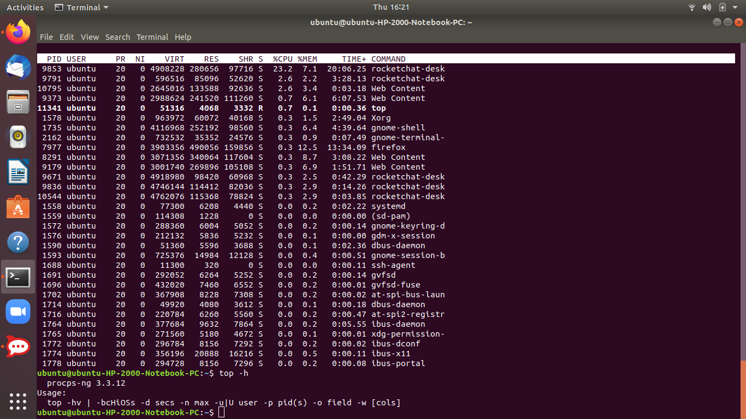

**Now learning about Htop Command in Linux:**

**htop** command in Linux system is a command line utility that allows the user to interactively monitor the system’s vital resources or server’s processes in real time. *htop* is a newer program compared to [*top*](https://www.geeksforgeeks.org/top-command-in-linux-with-examples/)command, and it offers many improvements over top command. htop supports mouse operation, uses color in its output and gives visual indications about processor, memory and swap usage. htop also prints full command lines for processes and allows one to scroll both vertically and horizontally for processes and command lines respectively.

Thats why it was important to learn about top first and how htop is better than top.

1. **How install htop:** we enter the following command to install htop program .If we simply type htop on the terminal we will see that command htop was not found. So to install htop we write the following command:

$ sudo apt install htop

And wait till it gets installed.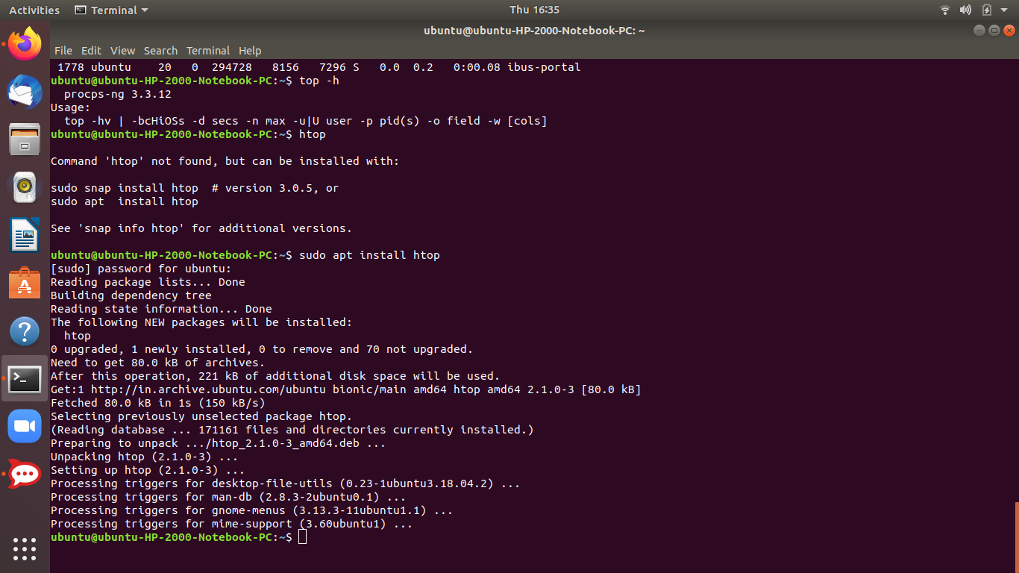

Then simply by entering the htop command we get the following results of running processes with a colored interface: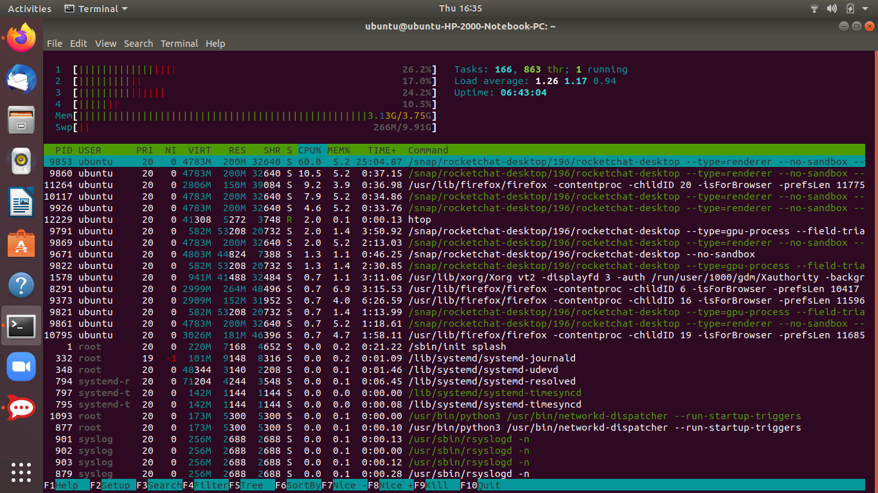

**2)To show only user processes:**user=USERNAME : Used to show only the processes of a given user.

htop -u username

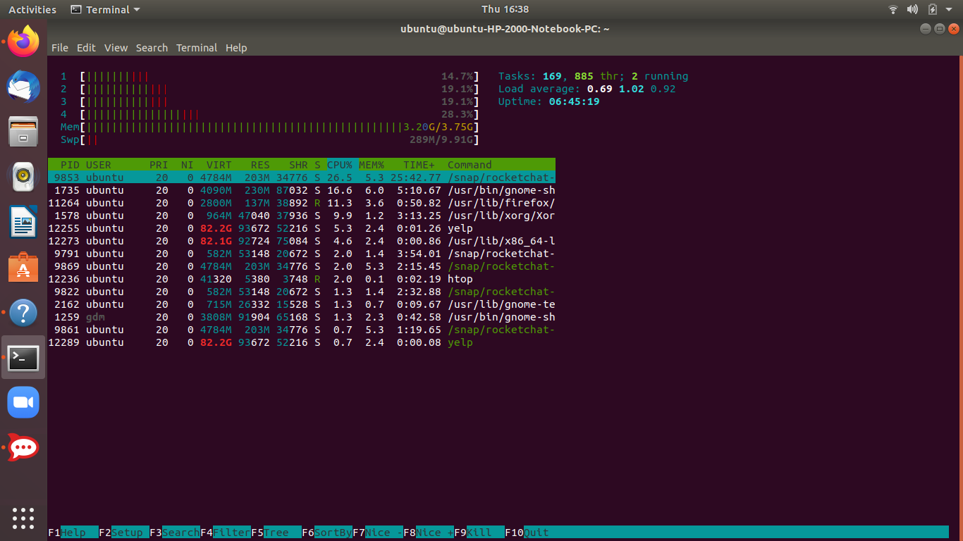

**3)Interactive Commands:**This is additional as compared to top previously as it adds an interactive interface to control the processes.They can be seen in the bottom line of the terminal and have multiple options:

* 
* **Arrows, Page Up, Page Down, Home, End**: Scroll the process list.
* **Space**: Tag or untag a process.
* **U** – Untag all processes (remove all tags added with the Space key).
* **s** – Trace process system calls.
* **F1** – Help : list of color codes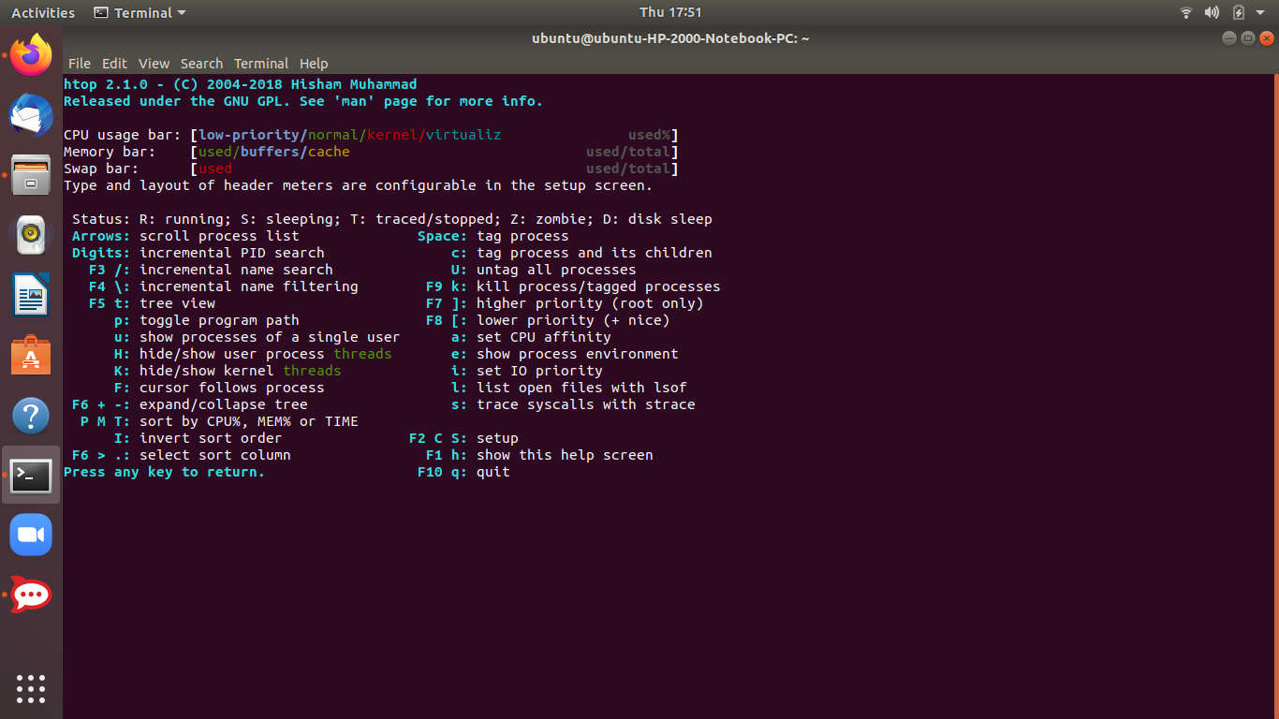
* **F2** – setup
* **F3** – search
* **F4** – filtering: type in part of a process command line and only processes whose names match will be shown.
* **F5** – Tree view,*gives parent child process unlike top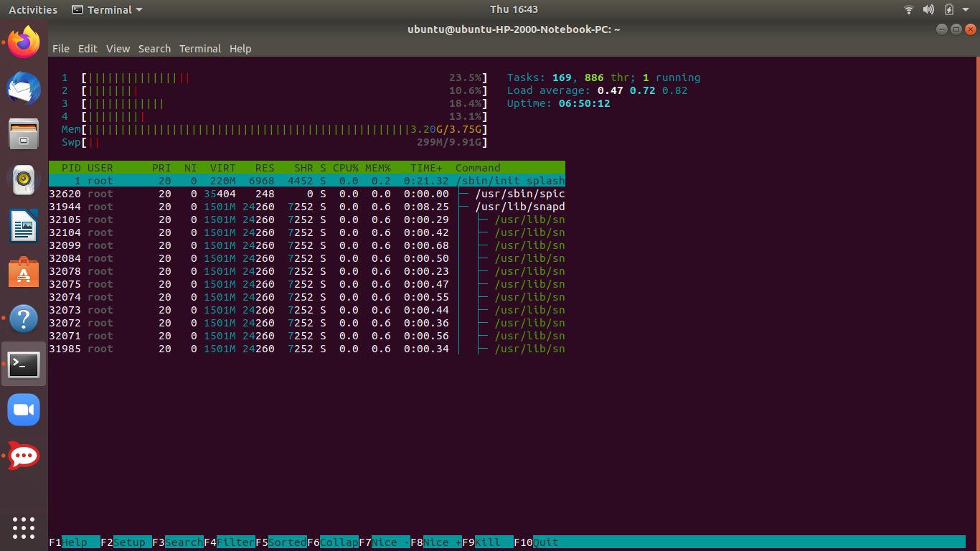*
* **F6** – Sorting,sorts process by PID,USER,PRIORITY,M_SIZE ,PERCENT_CPU so on and so forth.This comes in easy interface unlike top.Here we are sorting by percentage of CPU utilization.Rocketchat is showing highest % of cpu utilization.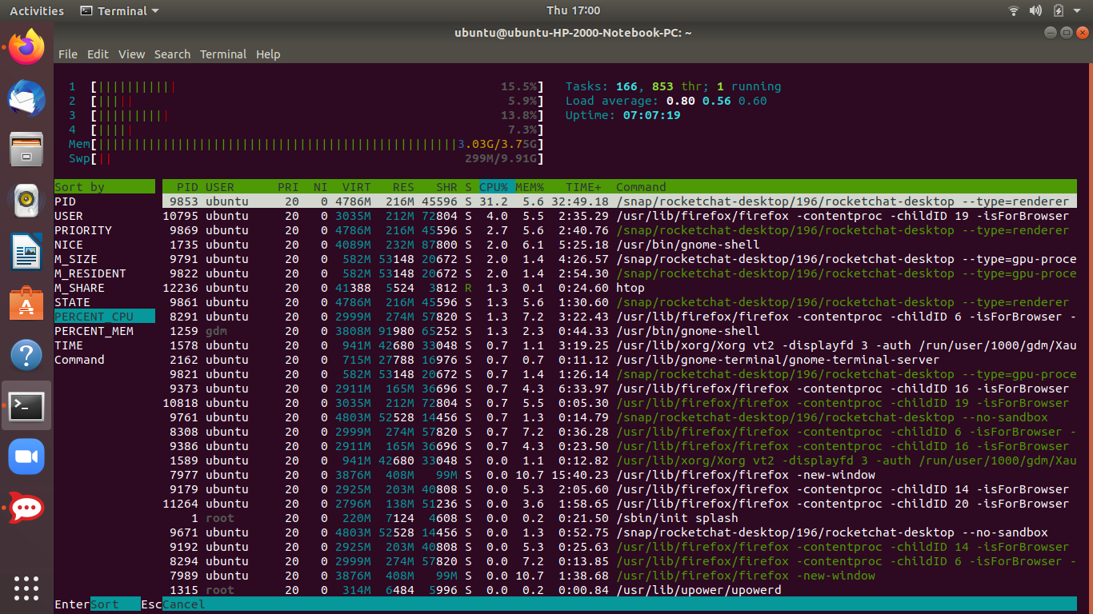
* **F7** – Increase the selected process’s priority. This can only be done by the superuser.
* **F8** – Decrease the selected process’s priority.
* **F9** –*This especially is a very easy and different way to kill a process in htop than in top Kill process.In top we see this thing differently where we actually have to note down the PID as said earlier while discussing top and then enter it on the terminal to terminate it after pressing k.But here in htop there is no need to mention PID.We simply need to select the process and press the kill option and select SIGTERM 15 and terminate the process.*

*As an example I have opened zoom on another tab and the killed it in the same way.The screenshots will make it clear.*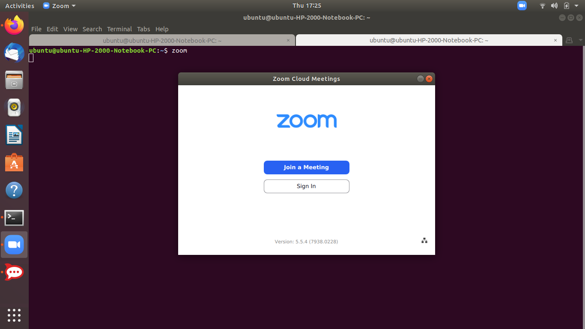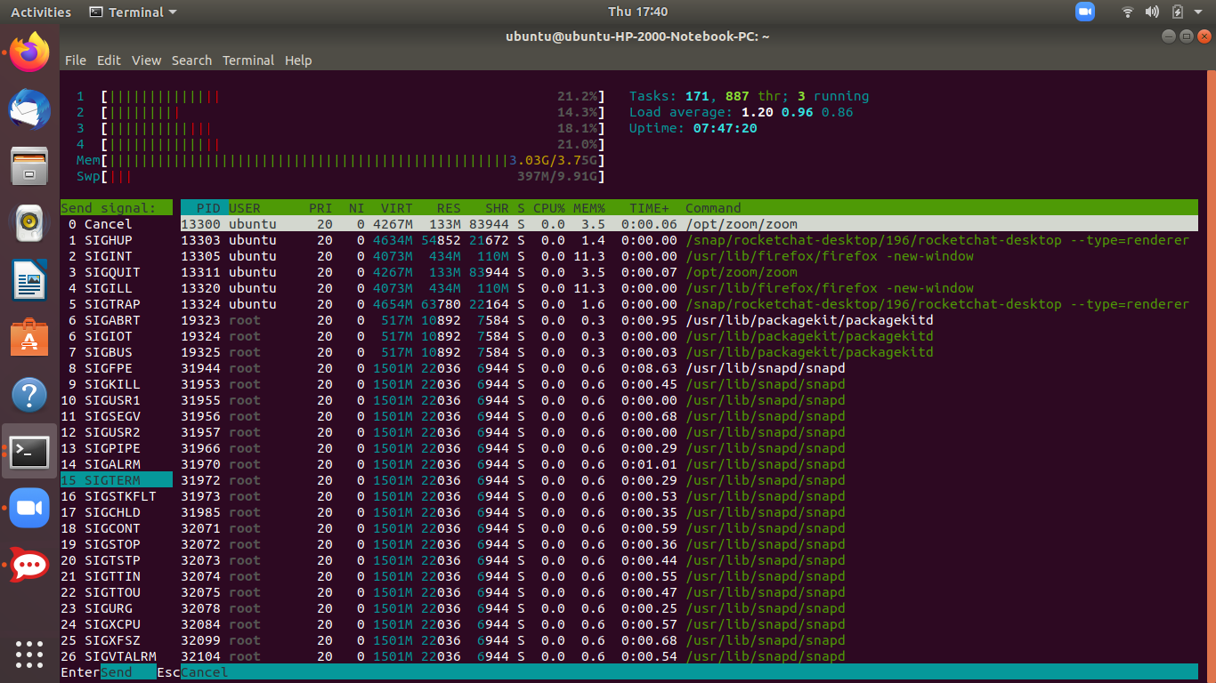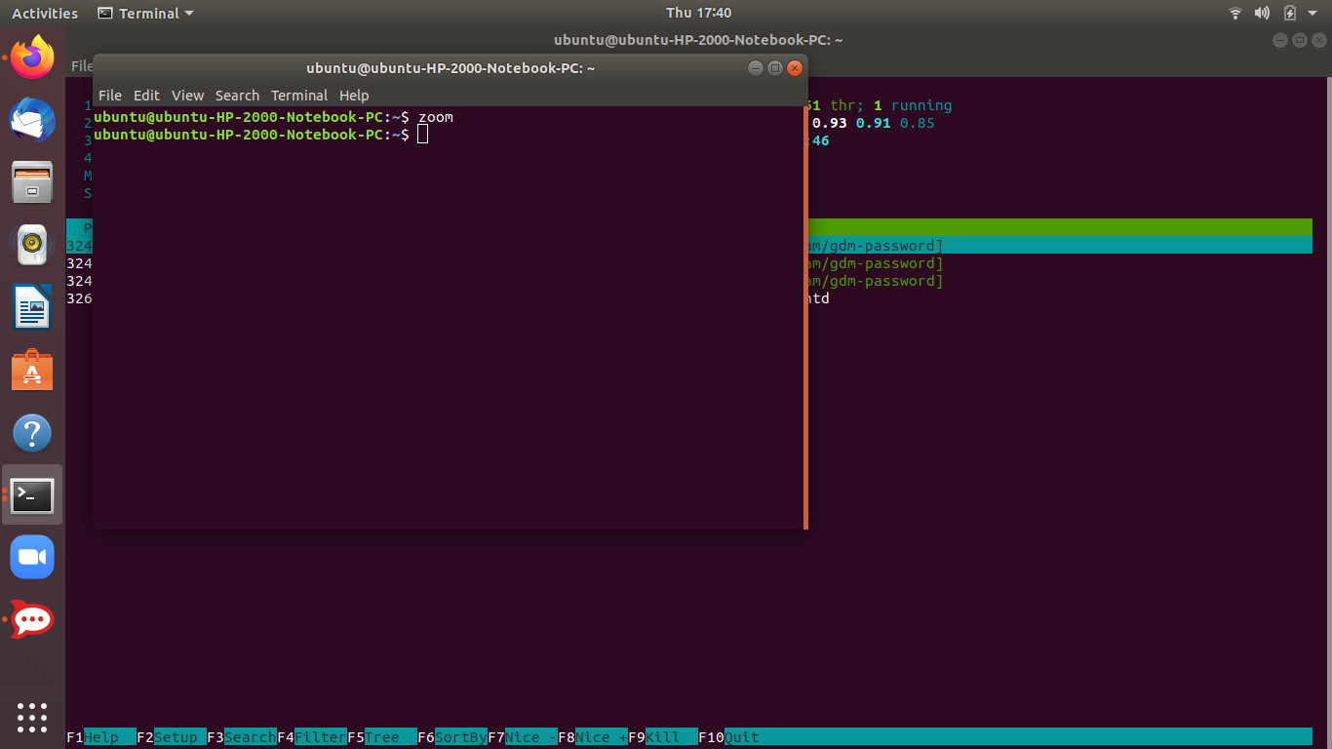

* **F10** – Quit.Lastly quit to quit from the running processes on htop.

**Load average and how it is calculated internally too?**

**Load average –** is the average system load calculated over a given period of time of 1, 5 and 15 minutes.

**System load**– is a measurement of CPU over or under-utilization in a Linux system; the number of processes which are being executed by the CPU or in waiting state.

In Linux, the load-average is technically believed to be a running average of processes in it’s (kernel) execution queue tagged as running.

**How To Calculate Load-Average internally**

Load average actually gives us the performance of the currently running processes in our system.In linux, it also includes processes in sleep states,those waiting for I/O resources etc.There are many ways of monitoring system load average including **uptime** which shows how long the system has been running, number of users together with load averages:

A downright idle Linux system may have a load average of zero, excluding the idle process.

**1)Uptime** is a command that returns information about how long your system has been running together with the **current time**, **number of users with running sessions**, and **the system load averages** for the past **1**, **5**, and **15** minutes.

Command: $ uptime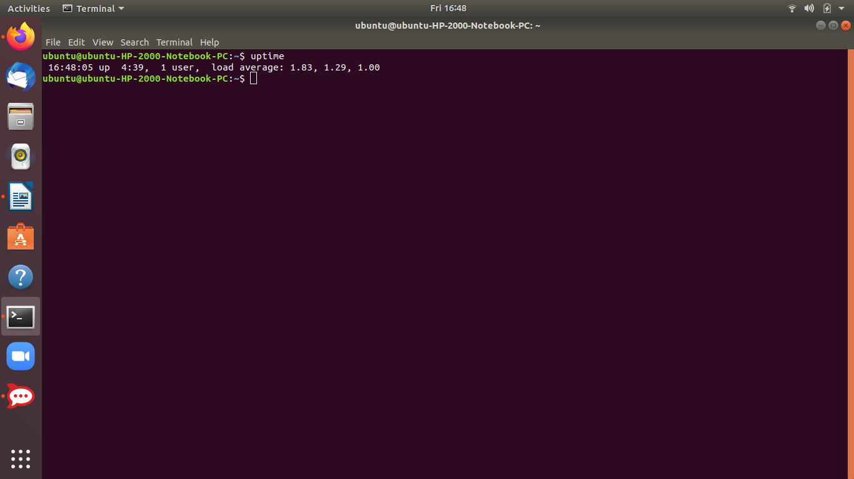

The numbers are read from left to right, and the output above means that:

* load average over the last **1** minute is **1.83**
* load average over the last **5** minutes is **1.29**
* load average over the last **15** minutes is **1.00**

*High load averages imply that a system is overloaded; many processes are waiting for CPU time.*

**2)** $ top command also gives us the load average of our system at the topmost line apart from our system’s running processes.From the screenshot you can observe: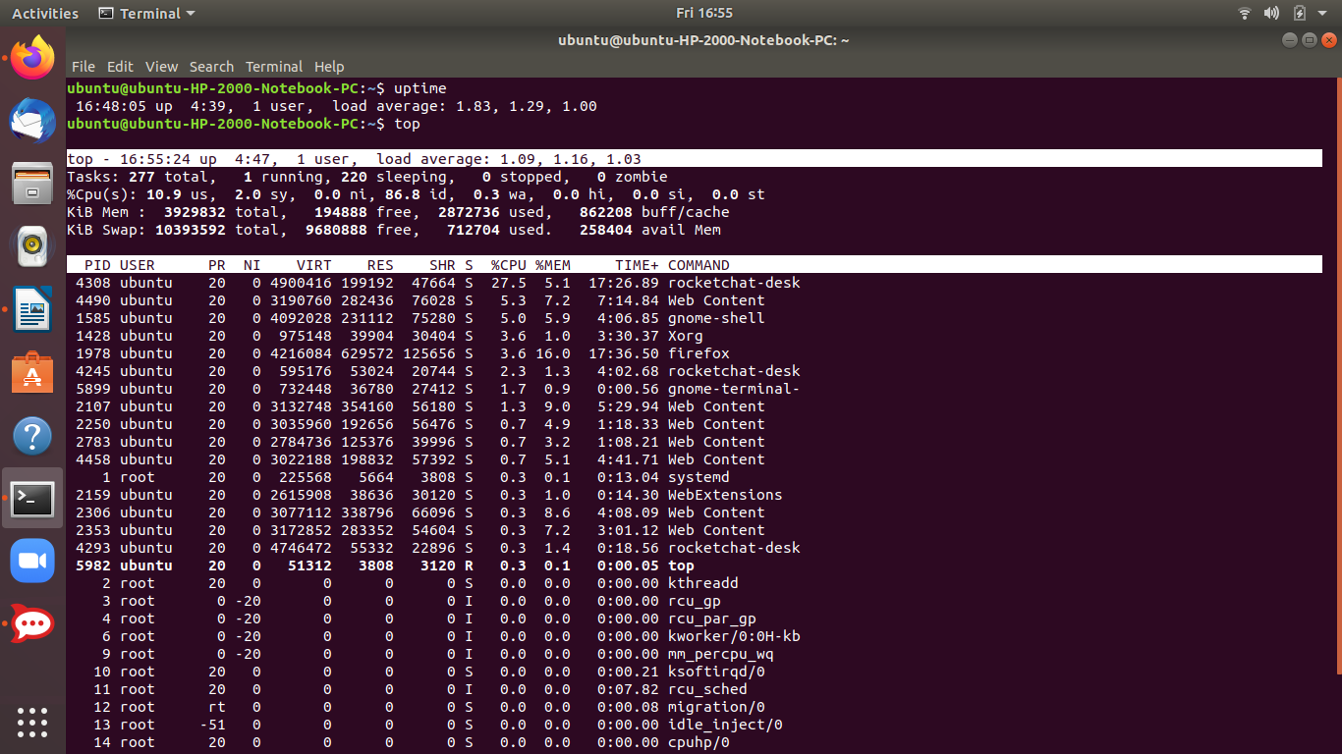

*Load average have to be compared with the no. of processors you have.If you have say 4 cores and your load average is 4 for the first 1 minute or 5 or 15 minutes then your cpu is overutilized and vice versa.*

**3)Using cat command :** Running the following command on the terminal

**$ cat /proc/loadavg**

Running this command gives us the results: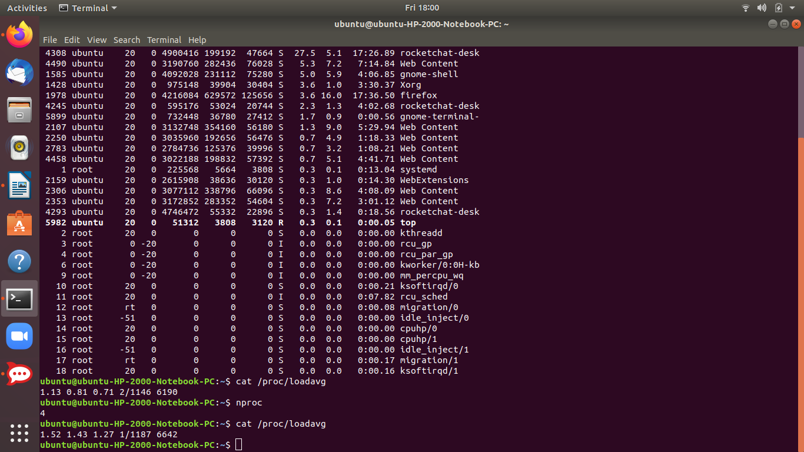

The first three fields are the load averages for 1 ,5,15 minutes.The fourth field consists of two numbers separated by a slash (/).

* The first of these (1 in my screenshot)is the number of currently executing kernel scheduling entities (processes, threads), this will be less than or equal to the number of CPUs.
* The value after the slash (1187 in my case) is the number of kernel scheduling entities that currently exist on the system.
* The fifth field (6642 in my case) is the PID of the process that was most recently created on the system.

**Advanced Linux Commands**

1. **Ifconfig :** ifconfig is used to configure the kernel-resident network interfaces. It is used at boot time to set up interfaces as necessary. After that, it is usually only needed when debugging or when system tuning is needed.

command: $ ifconfig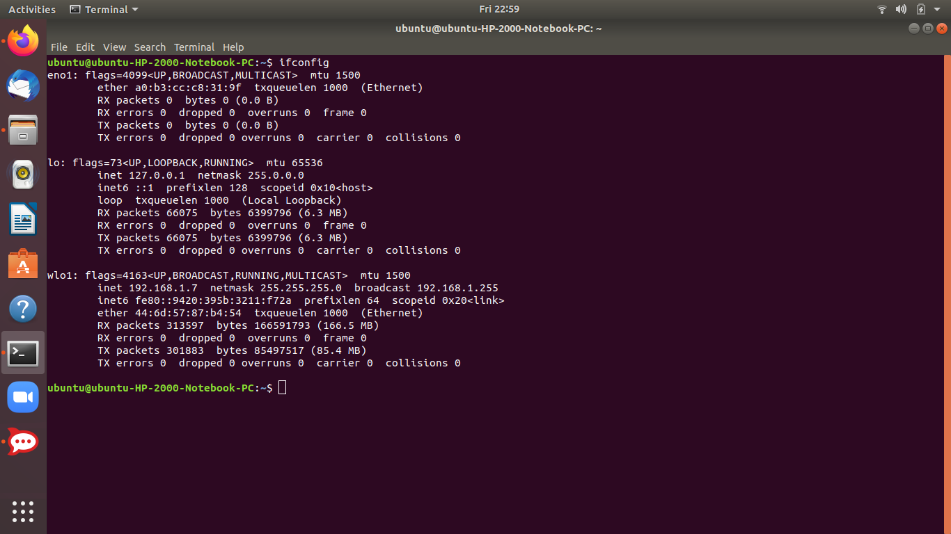

* eno1 is the onboard Ethernet (wired) adapter.
* lo is a loopback device. It can be imagined as a virtual network device that is on all systems, even if they aren't connected to any network.
* wlo1 is the wireless network interface.

**2) ifconfig -a** :checks all interfaces including disabled interfaces.

command: $ ifconfig -a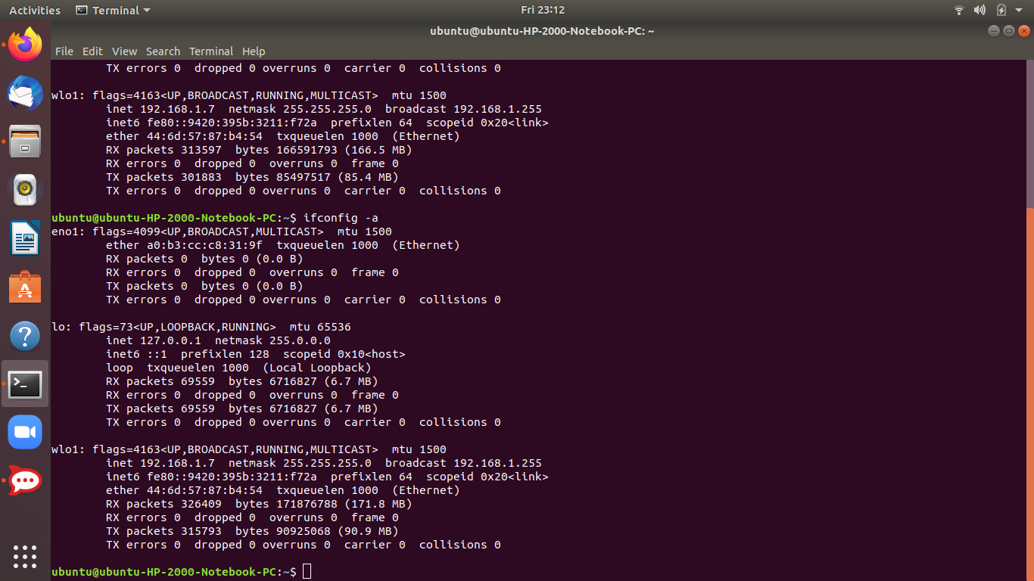

**3) Enable an Interface:** to enable an interface

$ ifconfig eno1(name of your interface) up

**4) Enable an Interface:** to enable an interface

$ ifconfig eno1(name of your interface) down

**5)For wireless network :** if using wireless network we use iwconfig instead of ifconfig:

command: $ iwconfig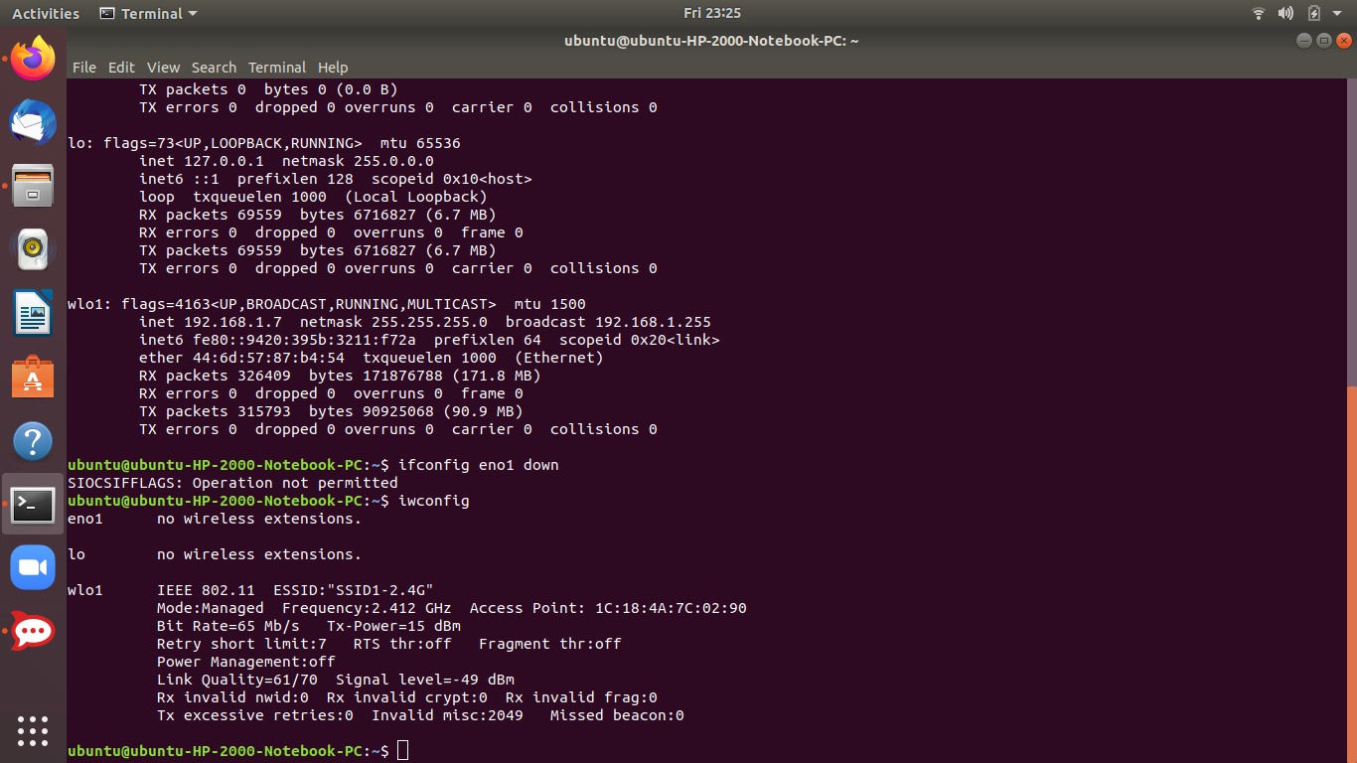

**6) iwconfig -a:** lists all wireless network interfaces including disabled interfaces.

command: $ iwconfig -a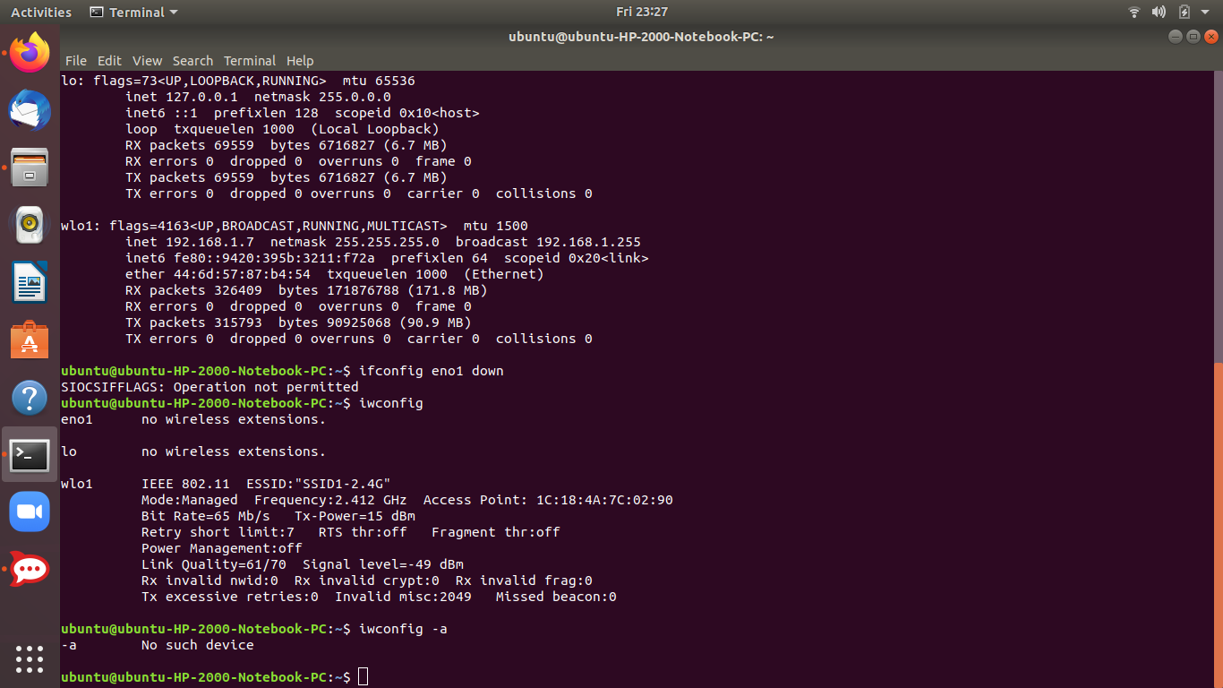

*Here we have no such disabled wireless device so it shows no such device.*

**7) netstat command :** displays various network related information such as network connections, routing tables, interface statistics, masquerade connections, multicast memberships etc.

command: $ netstat -a

It shows all tcp and udp ports as well as active unix domain sockets and servers as seen from the screenshots.

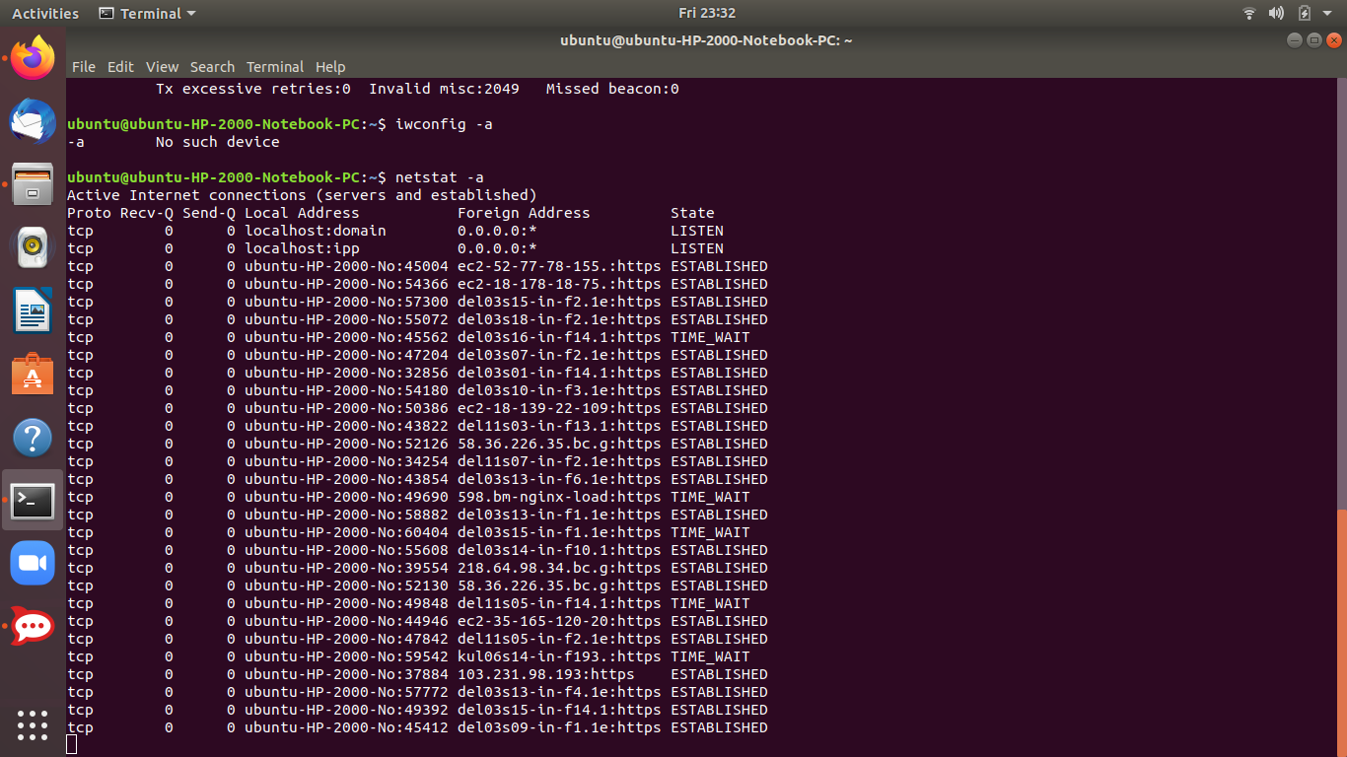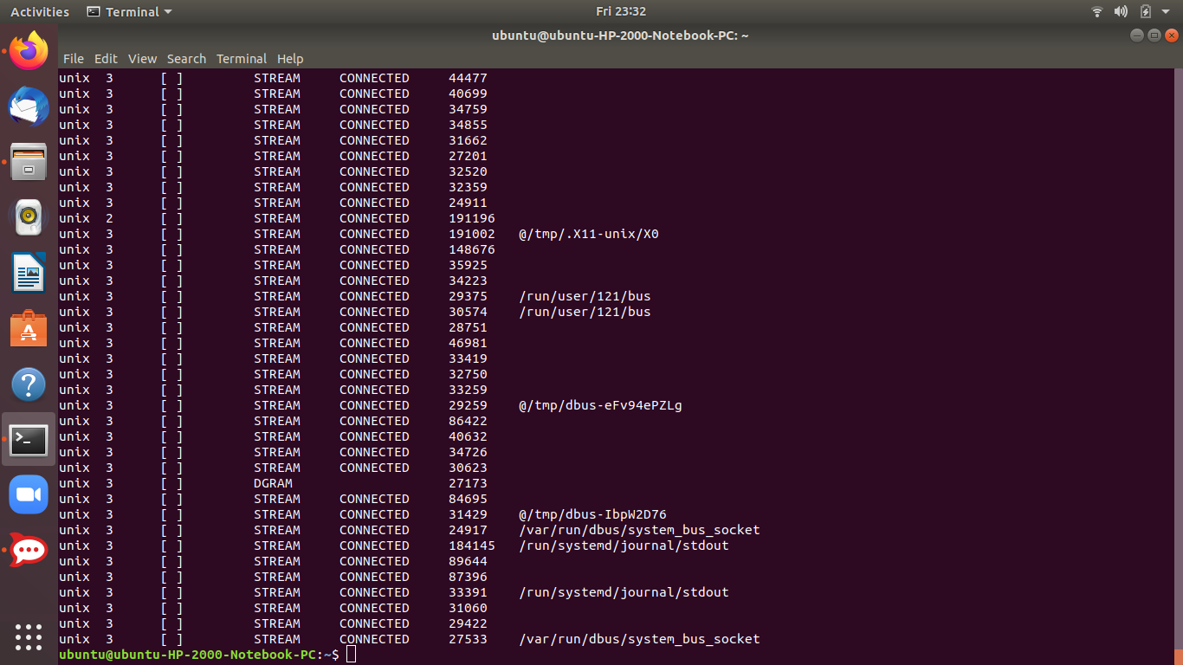

**8) Command: nslookup:** A network utility program used to obtain information about Internet servers. As its name suggests, the utility finds name server information for domains by querying **DNS**.

Command: $ nslookup appliedinformaticsinc.com

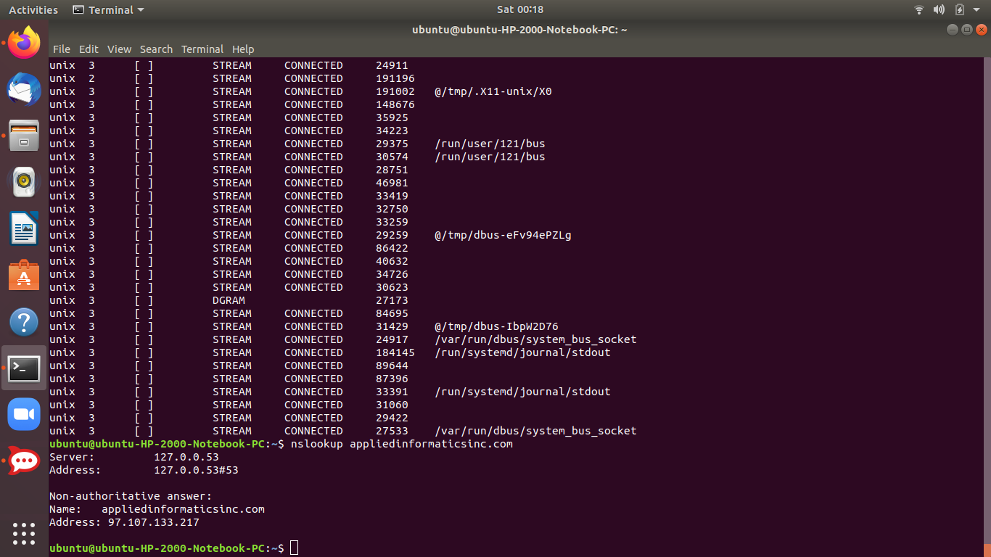

9)**Query Mail Exchanger Record:** A mail exchanger record (MX record) specifies the [mail server](https://en.wikipedia.org/wiki/Mail_server) responsible for accepting [email](https://en.wikipedia.org/wiki/Email) messages on behalf of a domain name. It is a [resource record](https://en.wikipedia.org/wiki/Resource_record) in the [Domain Name System](https://en.wikipedia.org/wiki/Domain_Name_System) (DNS).

Command: $ nslookup -query=mx appliedinformaticsinc.com

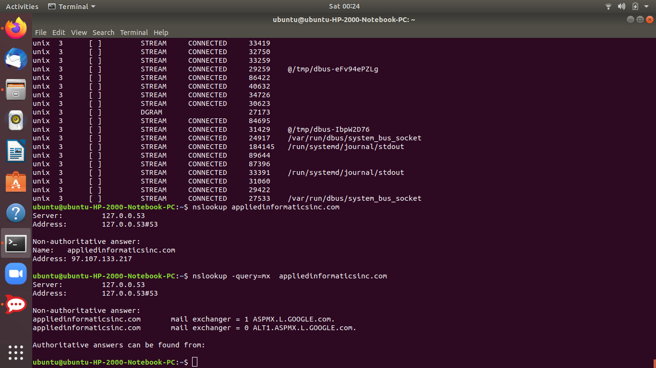

**10)Query Name server:**

$ nslookup -type=ns appliedinformaticsinc.com

**11) dig Command:** dig is a tool for querying DNS nameservers for information about host addresses, mail exchanges, nameservers, and related information. This tool can be used from any Linux (Unix) or Macintosh OS X operating system. The most typical use of dig is to simply query a single host.

Command: $ dig appliedinformaticsinc.com

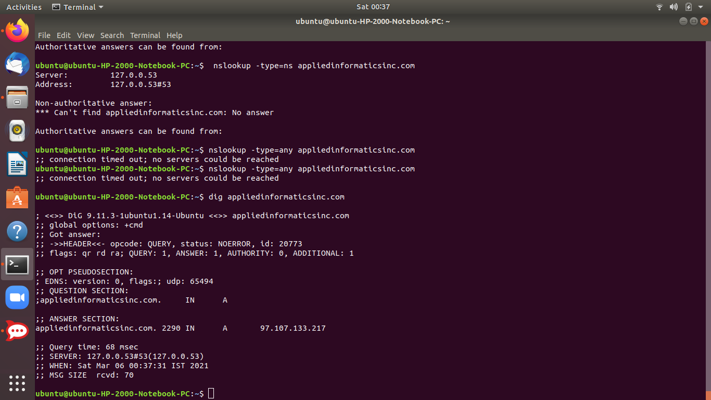

Command: $ dig bloom.ainfo.io trying to dig the DNS of rocket.chat;)

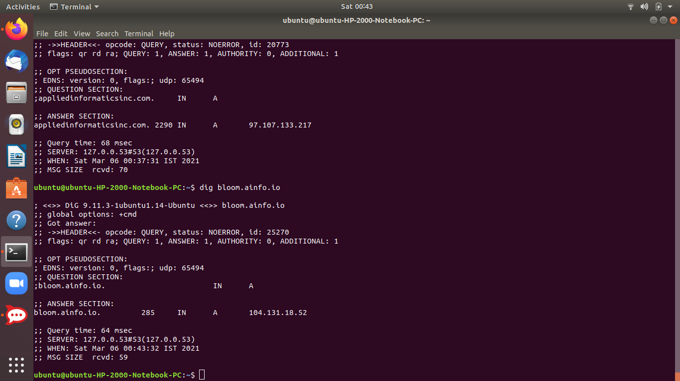

**User Creation and deletion in Linux:**

**1)User creation** In Ubuntu, there are two command-line tools that you can use to create a new user account: useradd and adduser.

[useradd](https://linuxize.com/post/how-to-create-users-in-linux-using-the-useradd-command/) is a low-level utility for adding users, while the adduser a friendly interactive frontend to useradd written in Perl.

To create a new user account named username using the adduser command you would run:

$ sudo adduser username

Here I already have a user ubuntu , I will create a new user mariam and give my details.

$ sudo adduser mariam

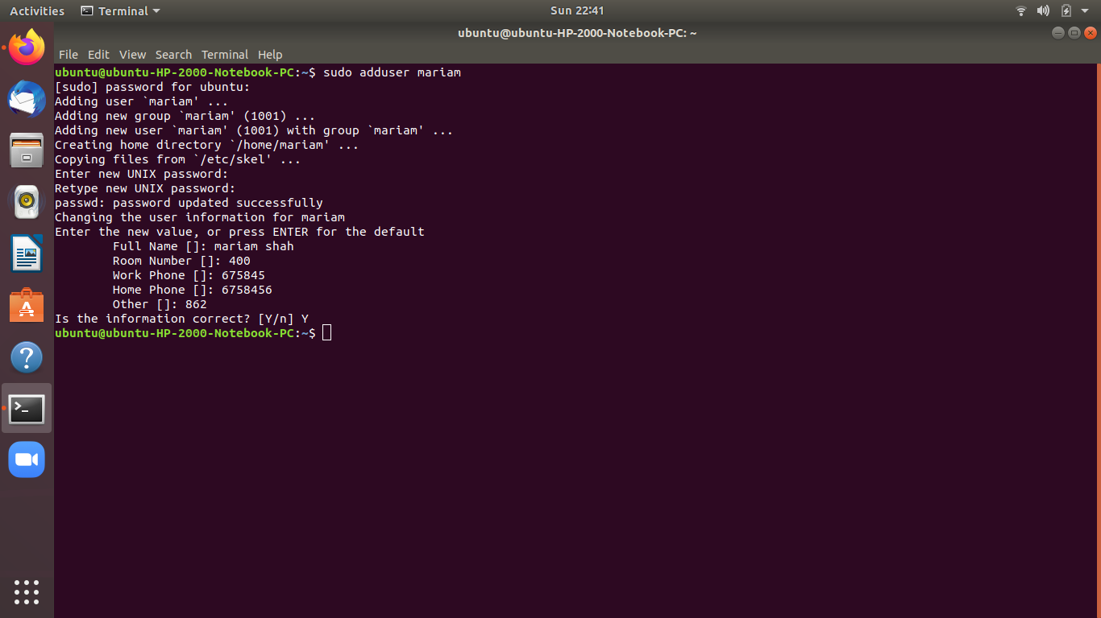

A series of questions will be asked. The password is required, and all other fields are optional.

Finally, confirm that the information is correct by entering Y.

The command will create the new user’s home directory, and copy files from /etc/skel directory to the user’s home directory. Within the home directory, the user can write, edit, and delete files and directories.

By default on Ubuntu, members of the group sudo are granted with sudo access.

2) If you want the newly created user to have administrative rights, [add the user to the sudo group](https://linuxize.com/post/how-to-add-user-to-group-in-linux/) :

sudo usermod -aG sudo username

**3) Deleting a user:** To delete the user, without removing the user files, run:

$ sudo deluser username

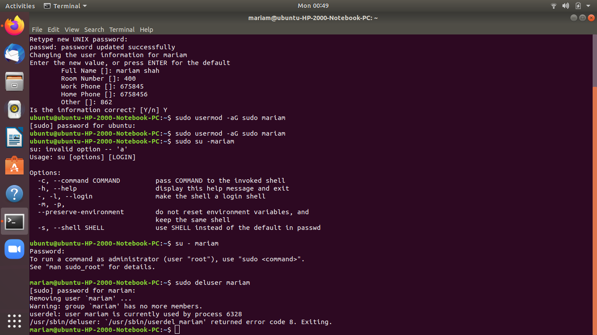

* **Deleting the user from the home directory and mail spool**,If you want to delete the user and its home directory and mail spool, use the --remove-home flag:

sudo deluser --remove-home username

USER Groups

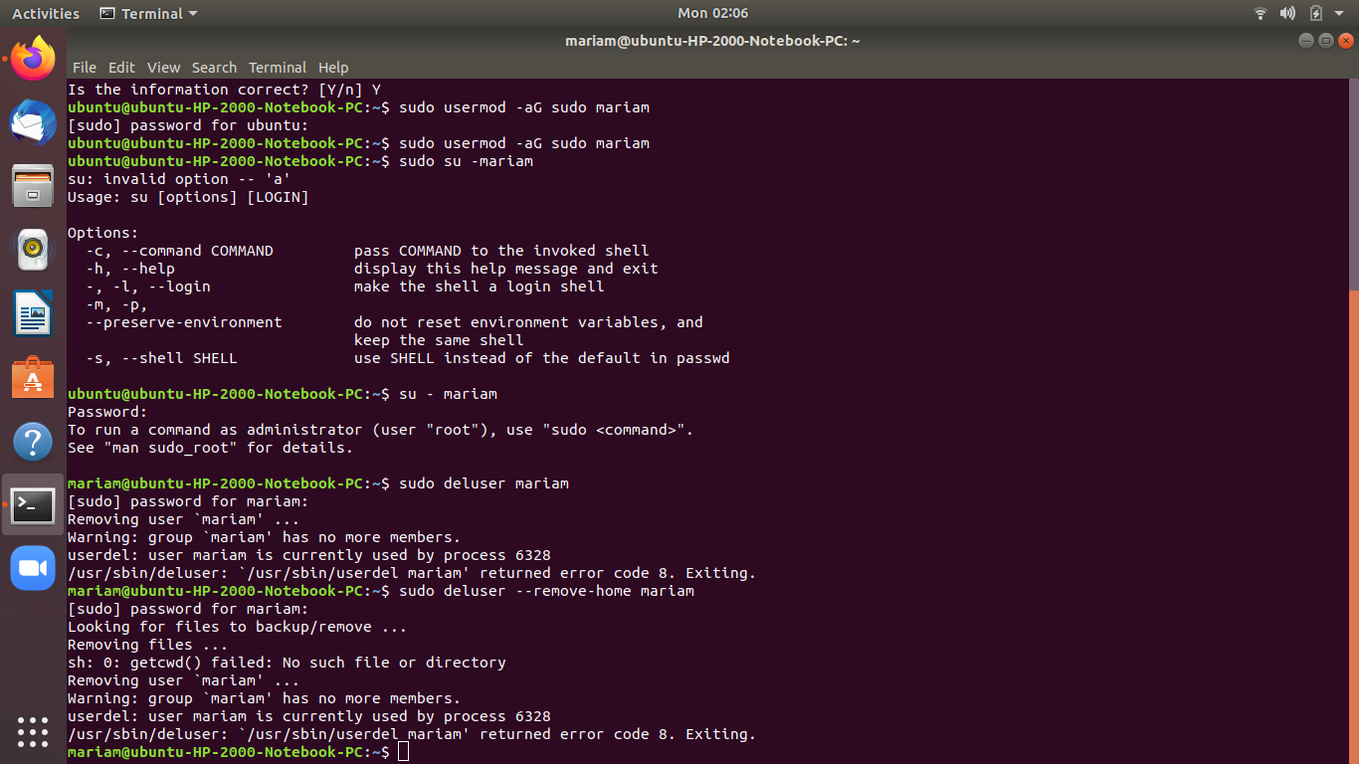

**File command in Linux with examples**

**File command** is used to determine the type of a file. ***.file*** type may be of human-readable(e.g. ‘ASCII text’) or MIME type(e.g. ‘text/plain; charset=us-ascii’). This command tests each argument in an attempt to categorize it.

**Syntax:**

file [option] [filename]

**1)Example:** Command displays the file type

$ file filename.txt

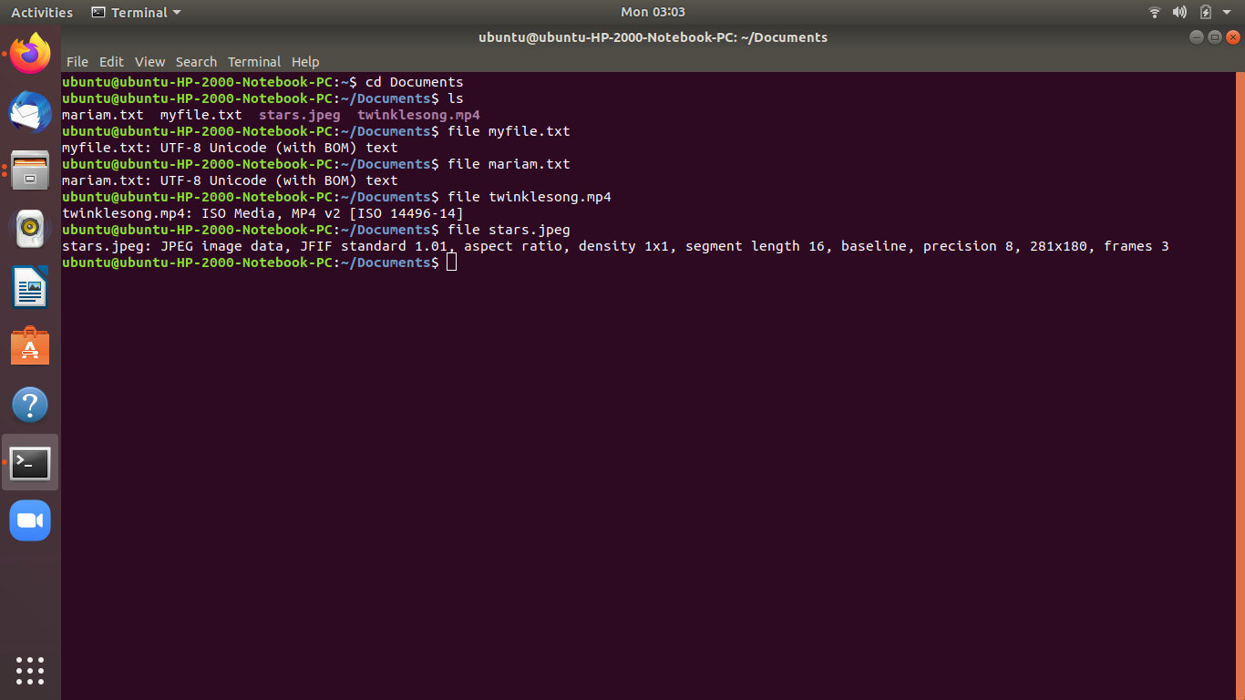

**Options:**

* **-b, –brief :** This is used to display just file type in brief mode.

**Syntax:**

file -b filename

* **\* option :** Command displays the all files’s file type.

file *

**directoryname/* option :** This is used to display all files filetypes in particular directory.

**Syntax:**

file directoryname/*

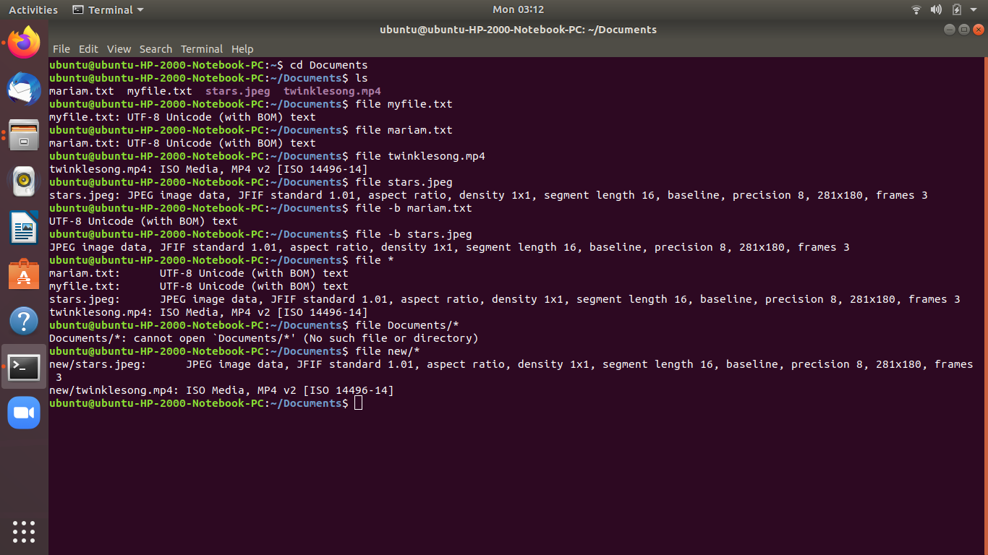

* **[range]* option:** To display the file type of files in specific range.

**Syntax:**

file [range]*

**Example:**

file [a-z]*

**-i option:** To view mime type of file.

**Syntax:**

file -i filename

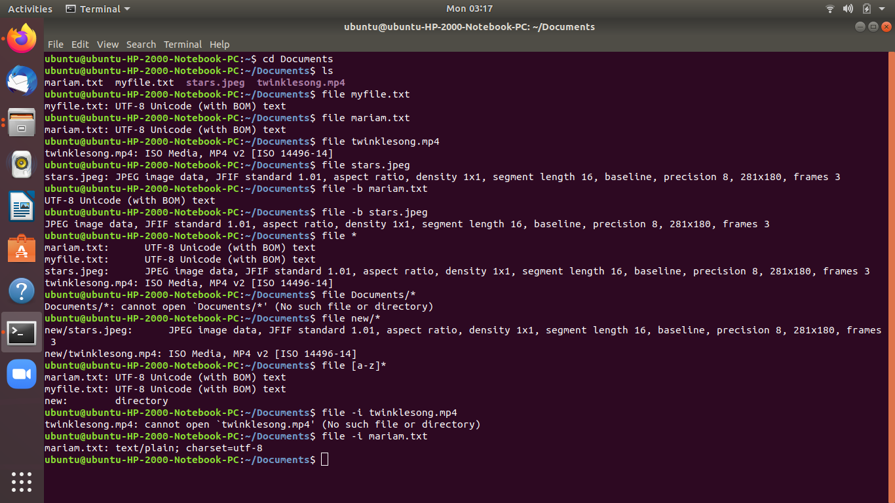

**Learning about the Directory Structures:**

The Linux File Hierarchy Structure or the Filesystem Hierarchy Standard (FHS) defines the directory structure and directory contents in Unix-like operating systems.It is maintained by the Linux Foundation.

* In the FHS, all files and directories appear under the root directory /, even if they are stored on different physical or virtual devices.

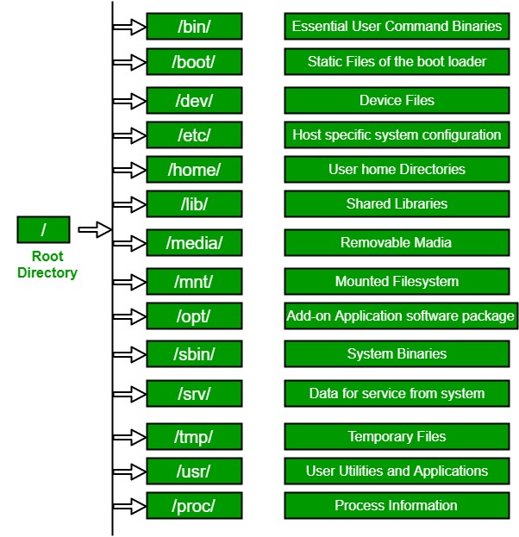

*Link reference:*<https://www.geeksforgeeks.org/linux-file-hierarchy-structure/>

**1. / (Root) :** Primary hierarchy root and root directory of the entire file system hierarchy.

* Every single file and directory starts from the root directory
* Only root user has the right to write under this directory
* /root is root user’s home directory, which is not same as /

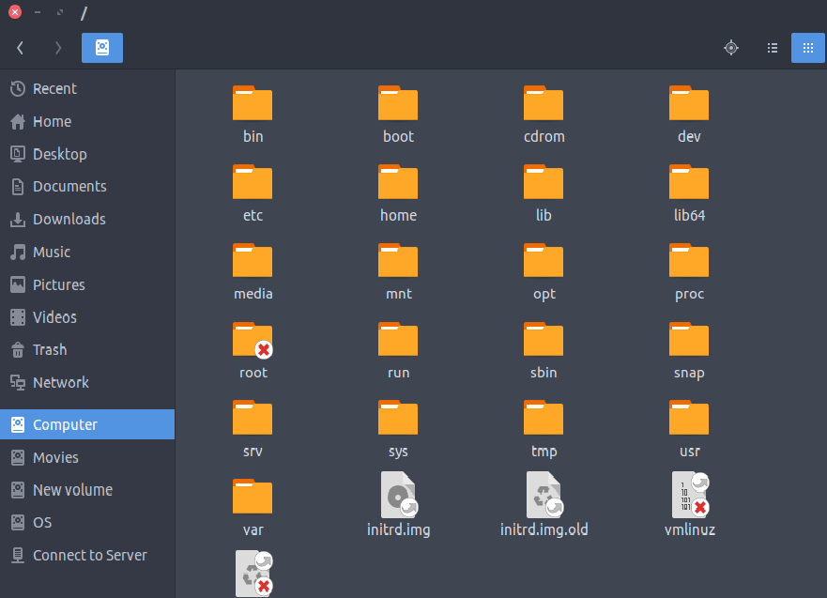

***Reference links:***

<https://www.thegeekstuff.com/2010/09/linux-file-system-structure>

<https://www.youtube.com/watch?v=o1pFLuls7TM>